Instructions and additional accessories

Syringe pump accessories:
- Power supply (Brand: Mean Well, NES-150-12)
  - Input:
    - 100-120 VAC 3.0 A
    - 200-240 VAC 2.0 A
  - Output: +12V 2.5 A
- Rainbow wires
- The Ground side (-) on Big Easy Driver go to the (-) port of power supply.
- The (+) on Big Easy Driver side go to the (+) port of power supply.
- Fuses (Little fuse Inc)
- Fuses are connected onto the (+) end of the wire.
- Fuses act as safety devices that they break when unusually high currents pass through.
- Fuse holders (350V 10A available, Little fuse Inc)
Safety concerns:
- Wrong wire connections would result short circuit and fire accidents.
- If the stepper motor is too hot that fingers cannot tolerate, turn the white trimmer screw on the Big Easy Driver off a little bit (counterclockwise).
Tools needed to make the syringes pumps:
- Soldering kit
- Headers
- Pin header strip (OdiySurveil)
- Tool box( wire cutters, wire strippers, screwdrivers… etc)
Syringe pumps cookbook:
- Print all the syringe pump parts with a 3D printer.
- Test your stepper motor first:
- Make the Big Easy Driver board (solder the header pins on the required places).

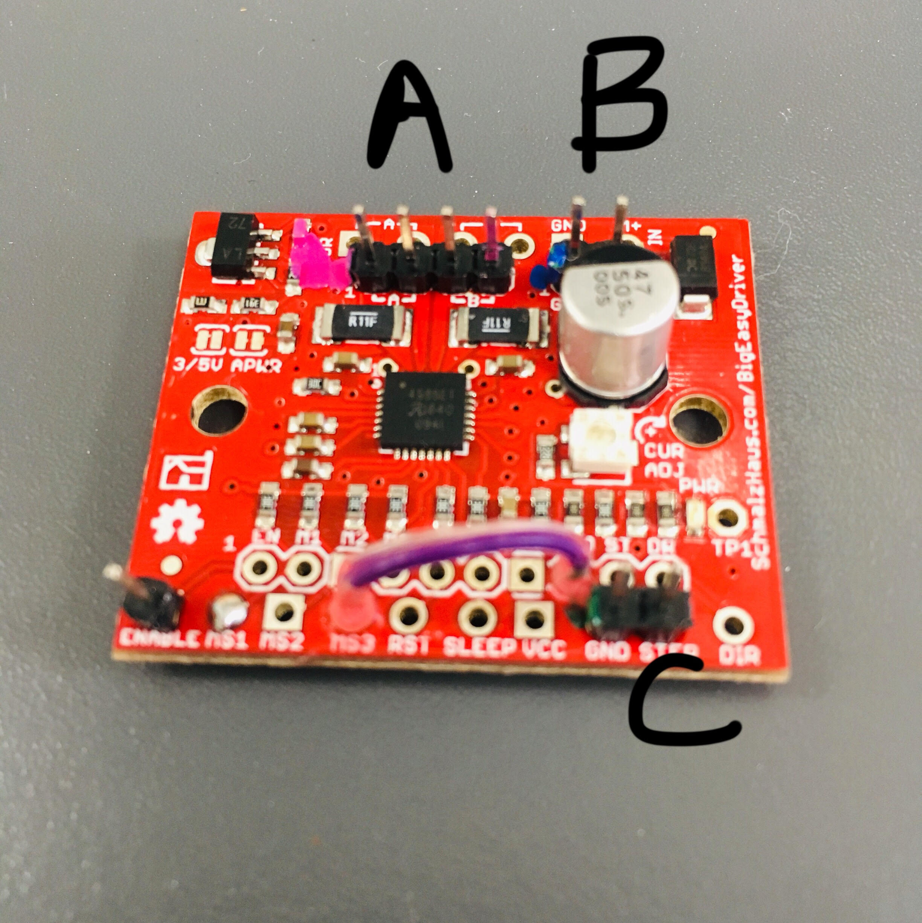
  - Install a 4-pin header on the [A][B] pin holes (A as picture shown).
  - Install a 2-pin header on the [ground] [M+] pin holes (B).
  - Install a 2-pin header on the [GND][STEP] pin holes (C).
  - Conenct [GND], [MS3] and [MS1] pin holes with a piece of wire (below).

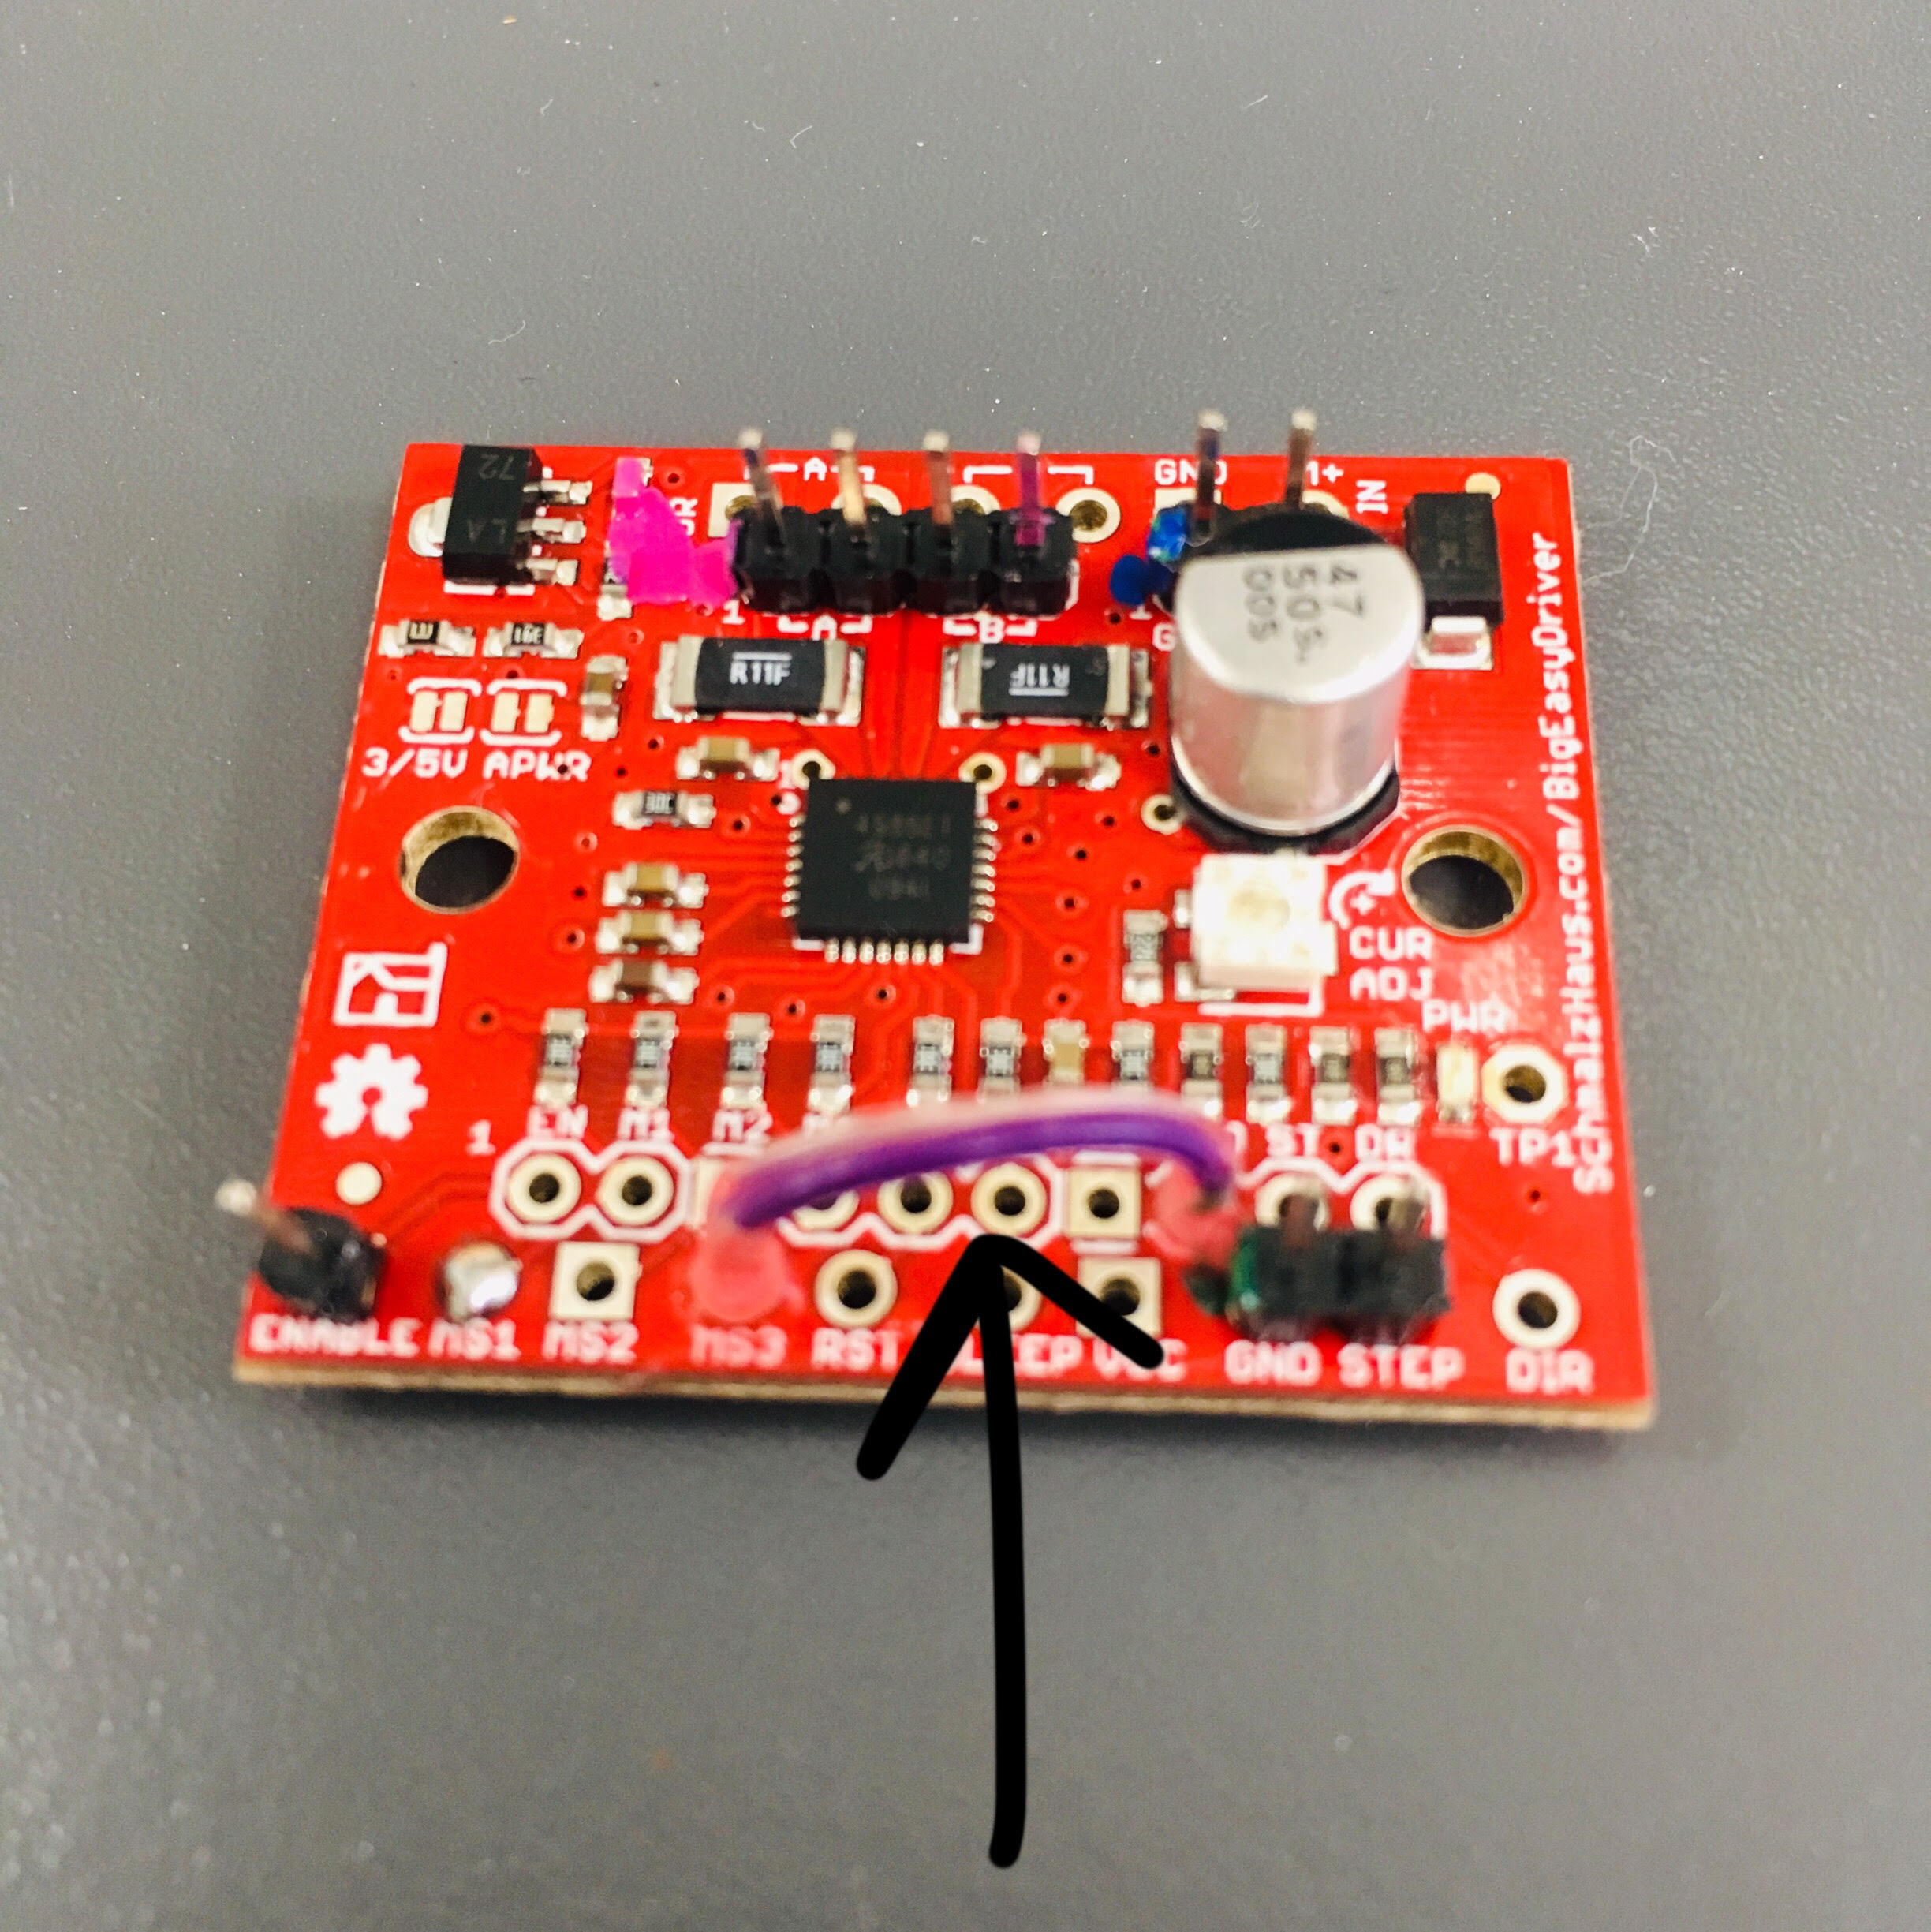

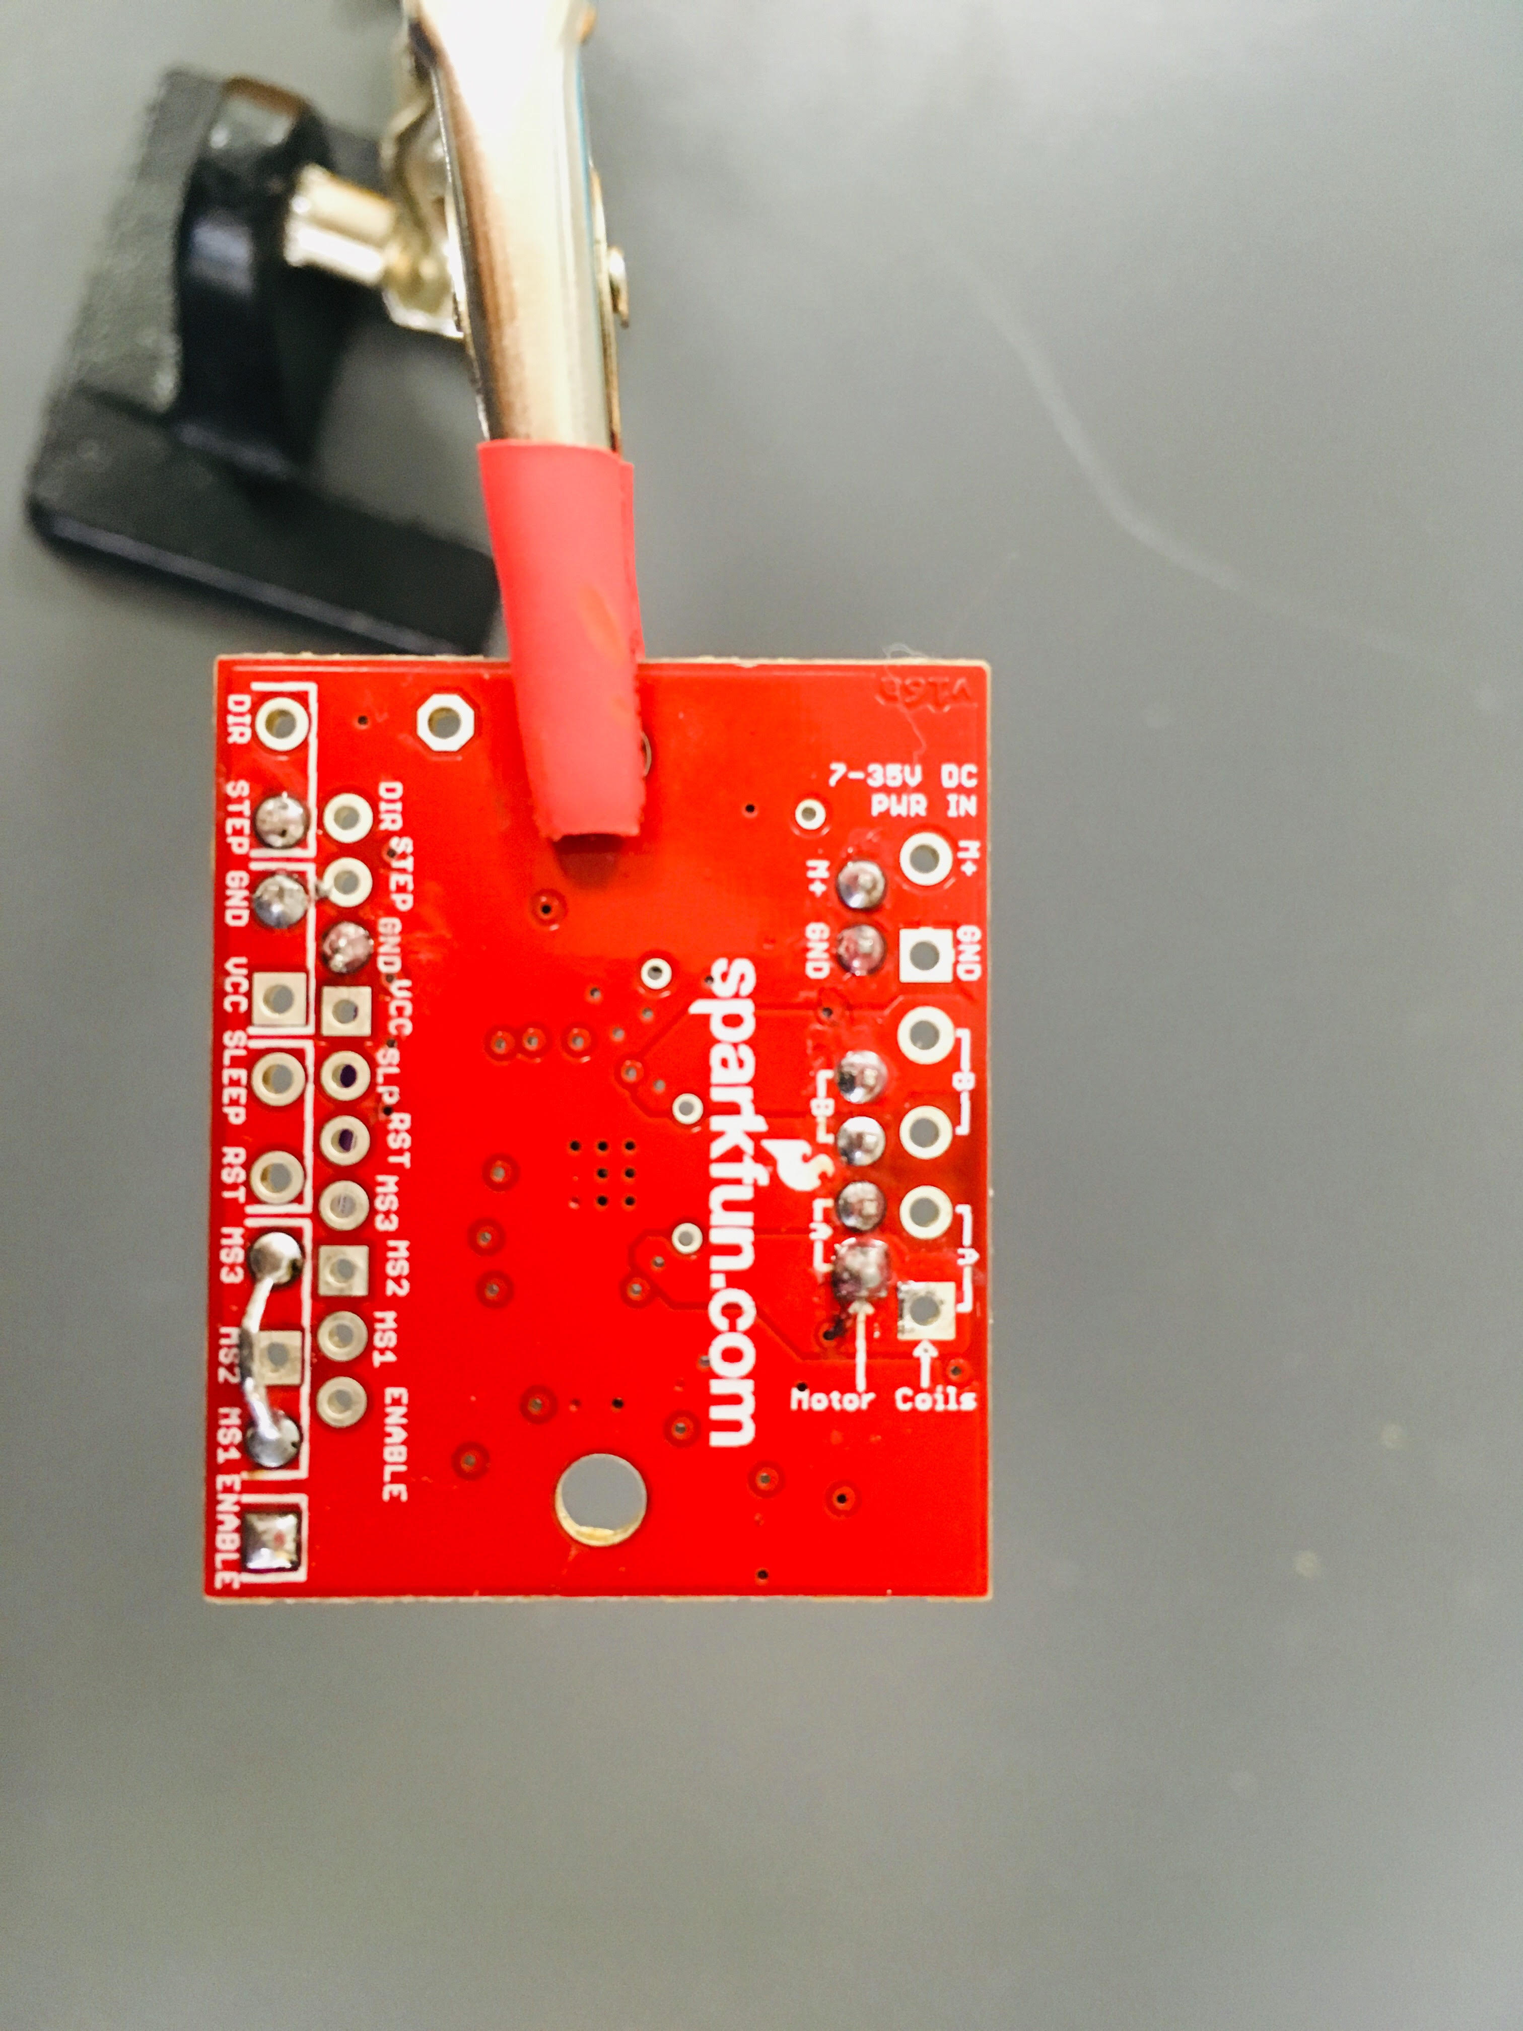

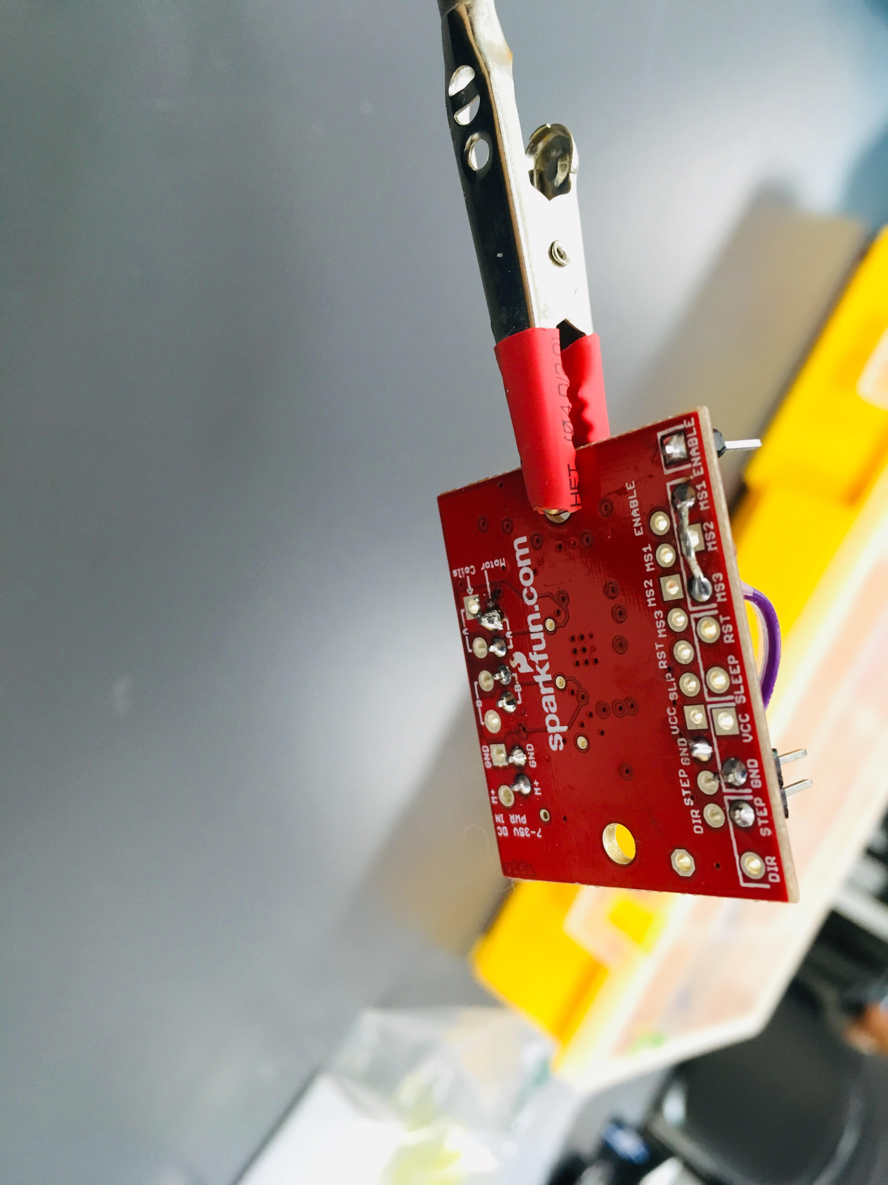

    - This is to control the number/direction of the motor turn on certain degrees.
- Solder a 4-pin header on the wires of the stepper motor (wire color sequence matters! Black, Green, Red, Blue)
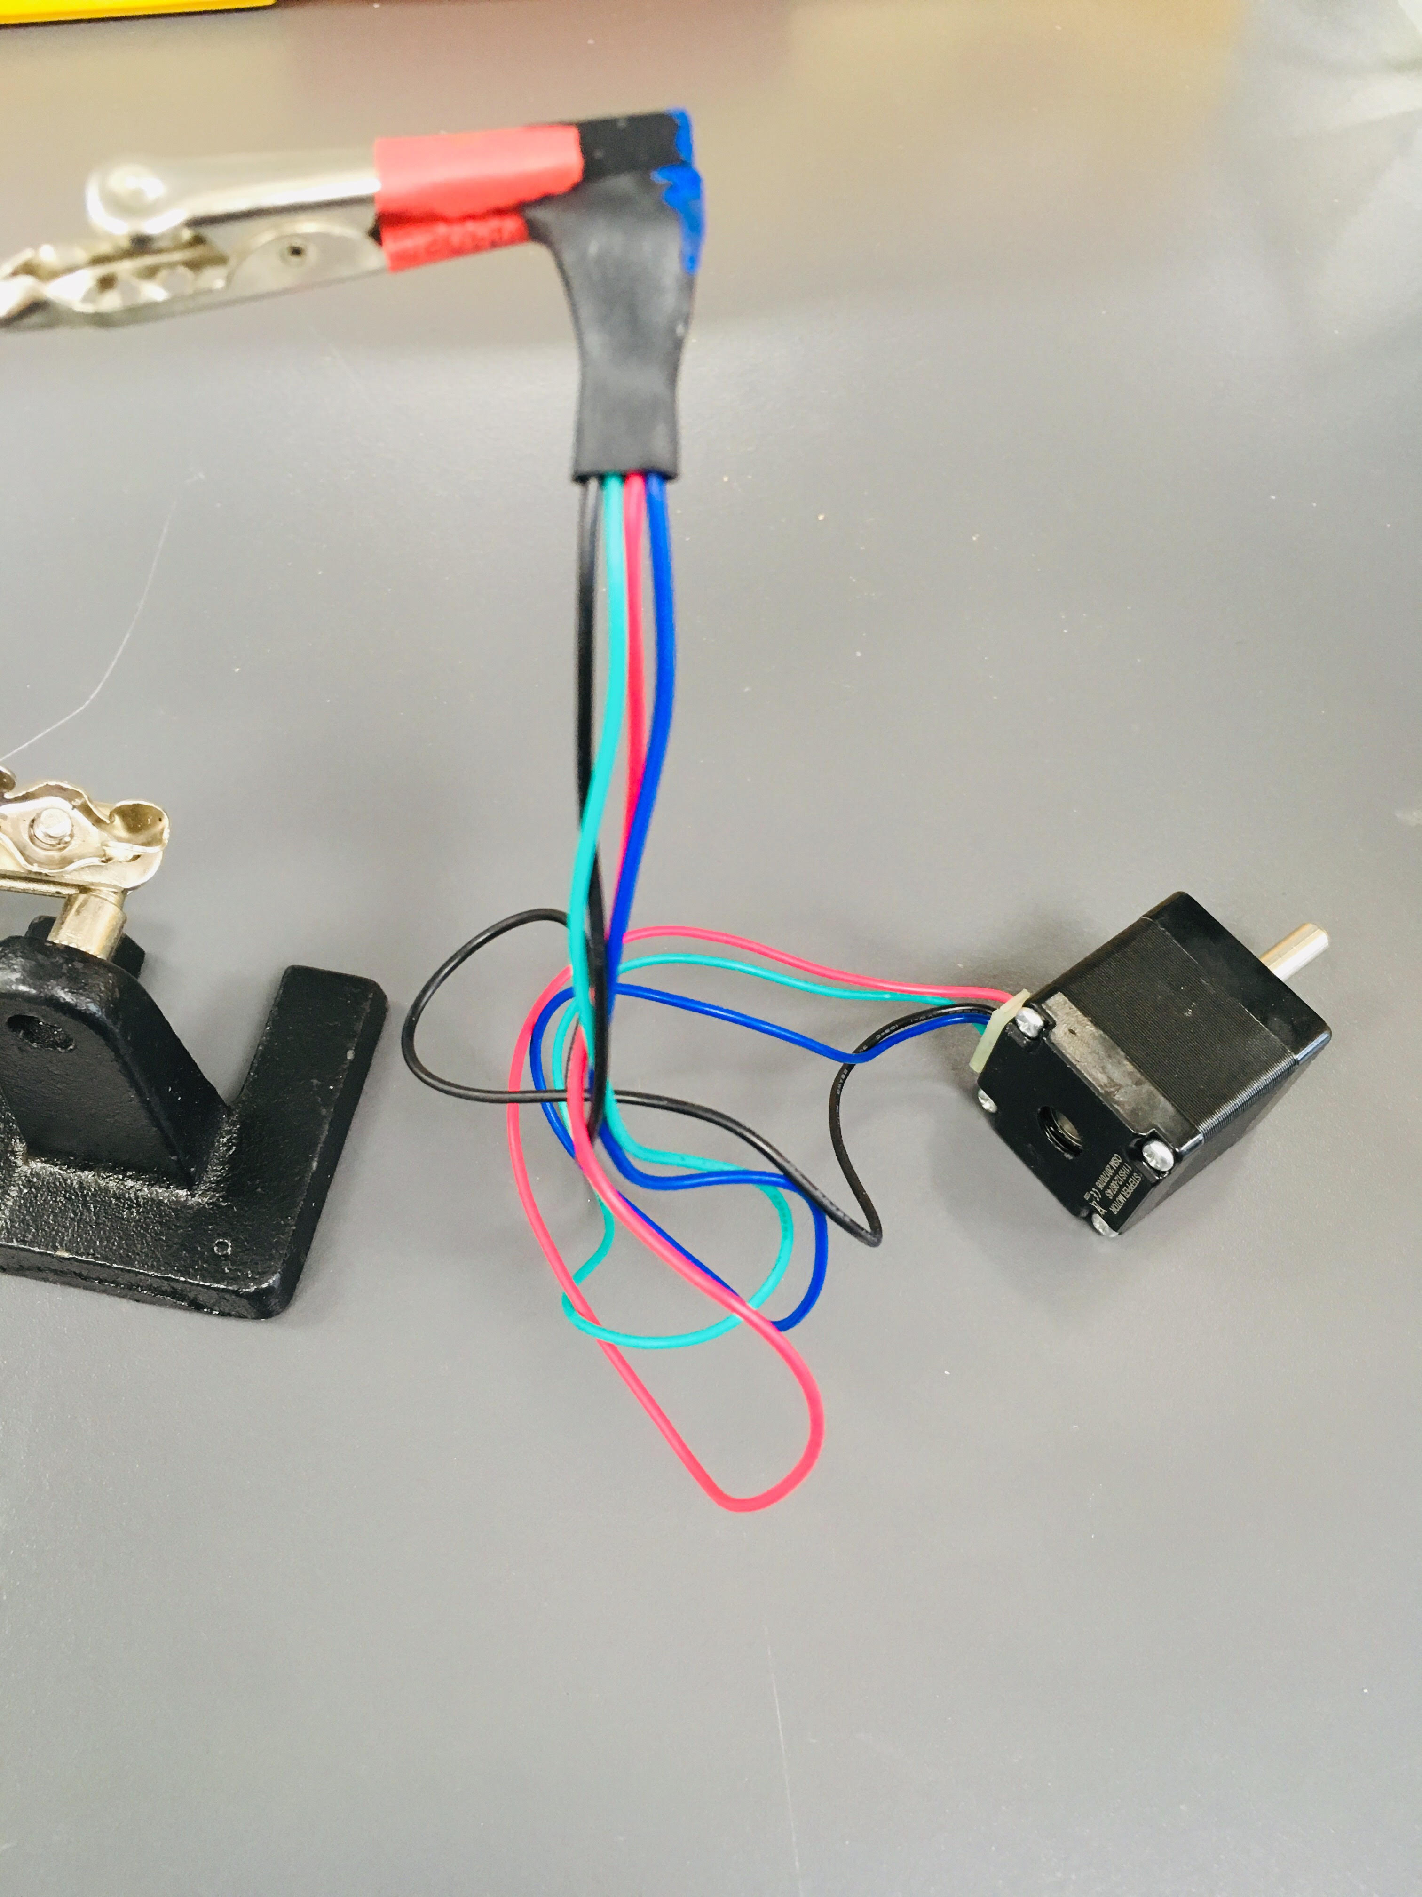
- Connect the stepper motor to the 4 pins on the Big Easy Driver.
- Connect the power supply pin ( [ground] [M+] pins) on the Big Easy Driver board to the power supply with wires.
- Turn on the power supply to see if the pole turns.
- Assemble all the 3D-printed parts together (including the stepper motor).
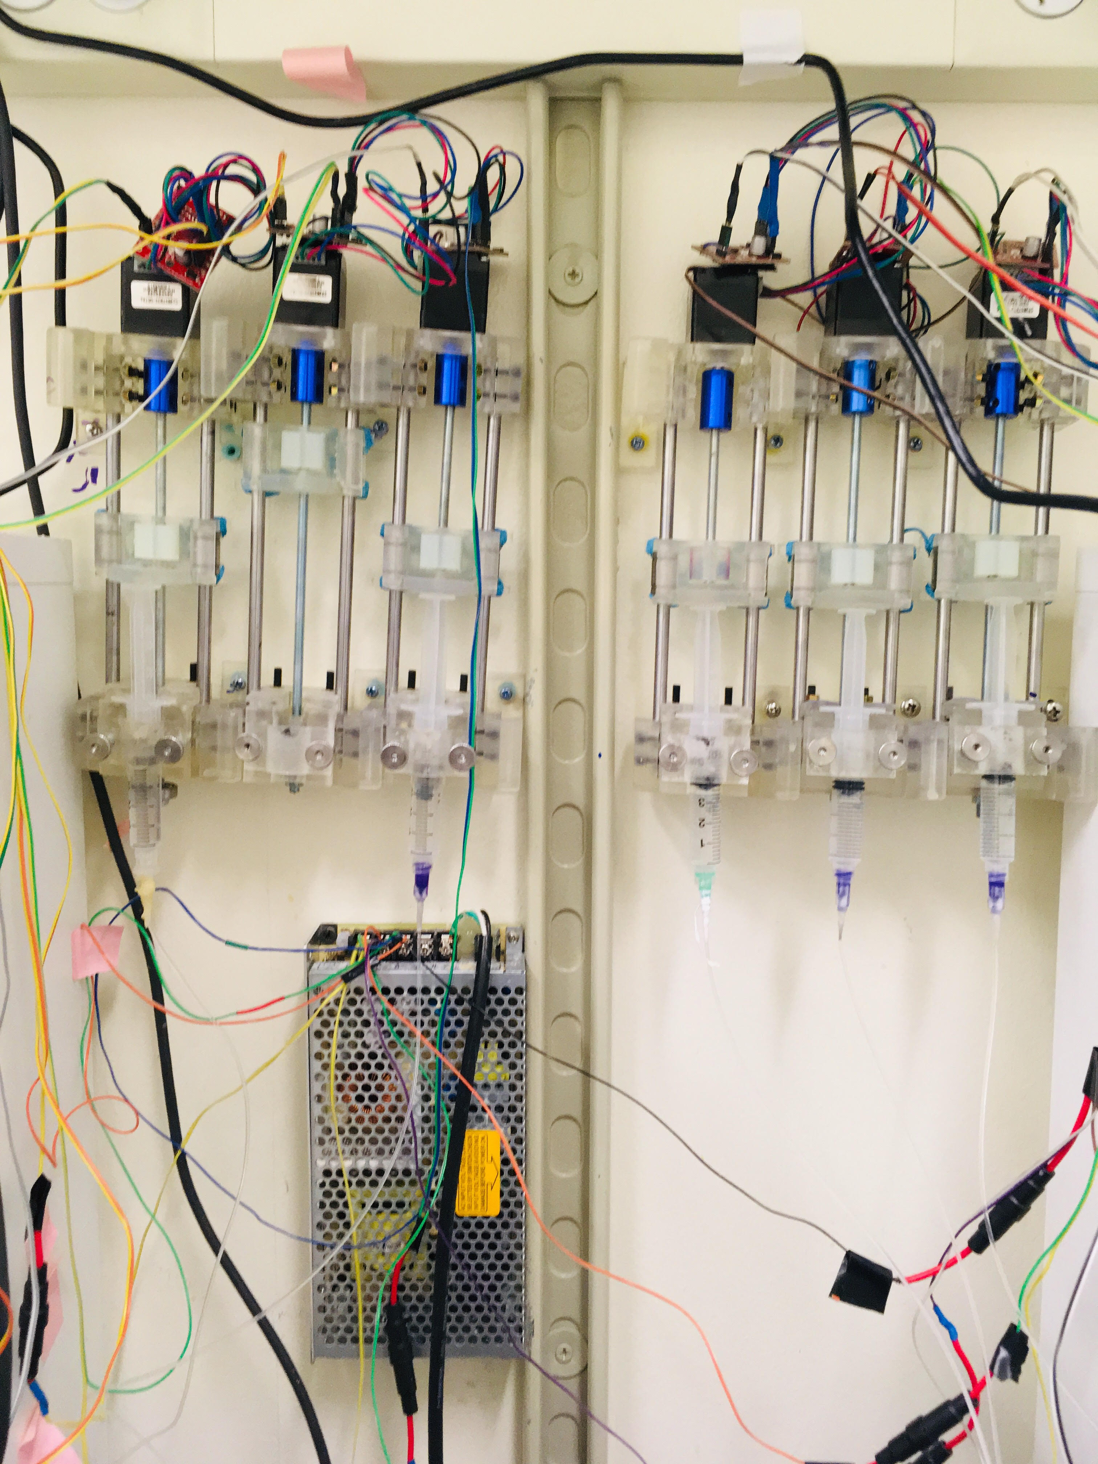

- Put the fuses in the fuse holders soldered onto your power supply wires.
- Connect the Big Easy Driver to the Arduino board with wires via pins [GND][STEP].
- Download the Arduino program on desktop.
- Control your syringe pumps.
- Go on GitHub -> Sjulson Lab-> behavior_box-> DUE_greenStandard_v7 to get the latest arduino code.

